Ideation Phase
Define the Problem Statements

Date | 02 Nov 2025
Team ID | NM2025TMID06777
Project Name | Optimizing User, Group, and Role Management with Access Control and Workflows
Maximum Marks | 2 Marks

Problem Statement:
In a small project management team consisting of a Project Manager (Alice) and a Team Member (Bob), there is a need to efficiently manage project tasks and ensure accountability throughout the project lifecycle. The current system lacks clear role definitions, access controls, and a structured workflow, leading to confusion regarding task assignments and progress tracking.

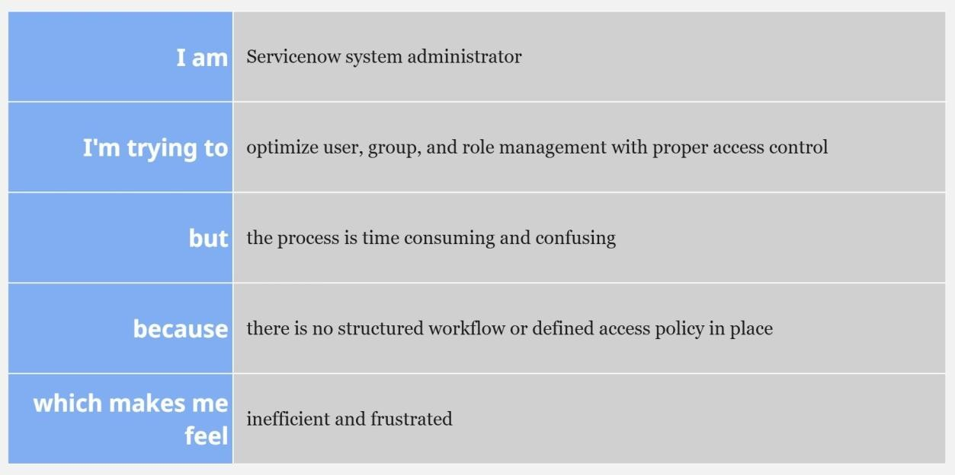

Problem  Statement (PS) | I am  (Customer) | I’m trying to | But | Because | Which makes me feel
PS-1 | A project  Manager | Manage  Users, roles, and project tasks efficiently | There’s no proper access control or defined workflow | roles and permissions are not  automated or clearly structured | frustrated and concerned about task  delays
PS-2 | A team Member | complete assigned tasks and update  progress easily | the system doesn’t notify or track my work  properly | there is no workflow tracking or progress update  mechanism | confused and demotivated

Problem Statement PS 1:
As a Project Manager, I am trying to assign and monitor project tasks, but the current system lacks clear role definitions, access controls, and a structured workflow. This makes it difficult to ensure accountability, track progress, and manage team responsibilities effectively. I need a more organized role-based access structure and workflow to streamline task management and improve project visibility.
Problem Statement PS 2:
As a Team Member, I am trying to view and update my assigned tasks, but the system does not clearly define my permissions or responsibilities. This leads to confusion about which tasks I own and how to report progress. I need a well-defined access structure and clear task visibility to perform my role efficiently and maintain accountability throughout the project lifecycle.

